Diva L. Mockford Polanco

**Project:** Retro Wizard

* **Part 1:** Independent game developers often do not have the budget, experience, or staff to produce a successful game.

Business Situation:

**Business Situation/Problems:**

**Background/Clarify the problem:**

* “Indy Games” or Independently developed games are…
  + typically developed by small development teams (1 to 20 people)
  + They have small budgets.
  + Use retro game, art style and mechanics to create original games.
* Why do independent game development teams fail?
  + Small budget
  + Inexperience develops (No professional experience)
  + Poor management

As a result of smaller budgets and inexperience, Indy game developers typically create games that can be labeled as retro.

* What makes a game retro?
  + Visual, audio, and mechanical elements influenced by the console limitations.
  + Typically associated with games created between 1980’s up until the 2000.
  + Example: the **NES color** palette contained only 54 usable **colors**, but only three can be used on a sprite or tile at a time.
  + The NES console had 5 voices/ channels each with a different wave.

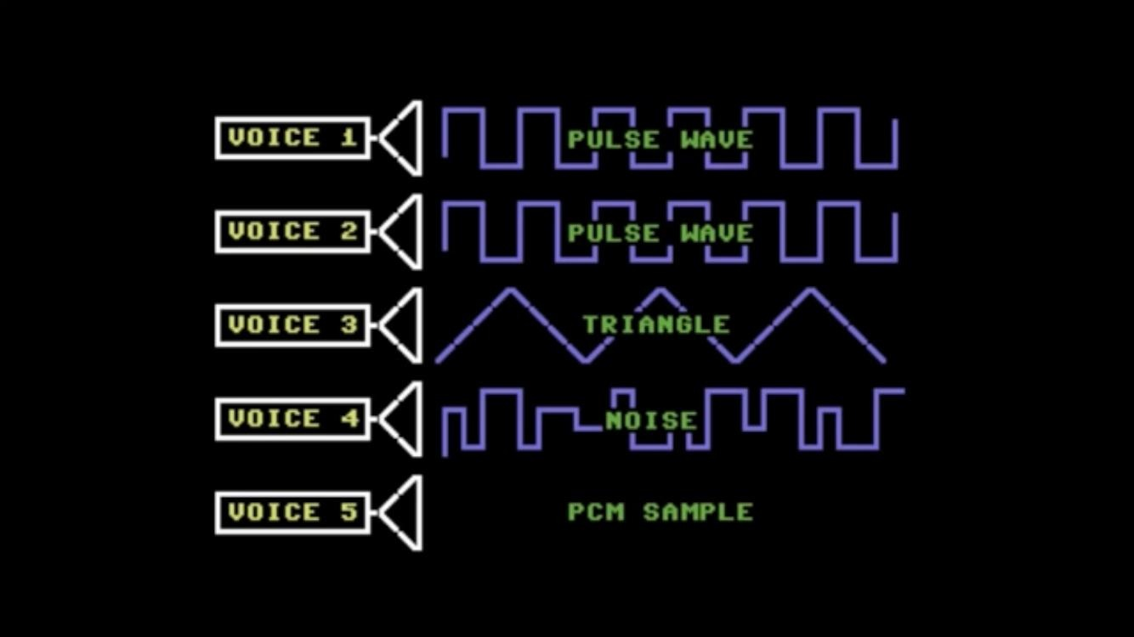

* + As a consequence of hardware limitations each console has produced a unique **style**(gameplay mechanics, art, animation, sound etc.) that players/users associate with that given console or game.
* Why retro?
  + Requires less skill, time, and computing power to develop. As a consequence, they are cheaper and faster to make than games with photo realistic character models and environments.

**Current situation:**

**Examples of successful and unsuccessful Indy developers:**

|  |  |  |  |  |  |  |  |  |
| --- | --- | --- | --- | --- | --- | --- | --- | --- |
| **Company Name** | **Project** | **Budget** | **Team Size** | **Number of programmers** | **Number of artist/Animators** | **Sound designers** | **Notable members of the team.** | **Tools used(Game engine…)** |
|  |  |  |  |  |  |  |  |  |
|  |  |  |  |  |  |  |  |  |
|  |  |  |  |  |  |  |  |  |
|  |  |  |  |  |  |  |  |  |
|  |  |  |  |  |  |  |  |  |
|  |  |  |  |  |  |  |  |  |

**The state of the independent game companies: (graph)**

**Tools available for independent game developers:**

**Game Engines:**

Unity

Unreal Engine

Game Maker Studio

**Art:**

Blender

Maya

**Sound**:

**Examples of Indy games that are based on retro games:**

Star Fox(1993,SNES)

 

ExZodiac( 2021 release, demo available since, Windows Mac)



---------------------------------------------------------------------------------------------------------------------

Grand Theft Auto(1997,PS1)



Hotline Miami(2012,Windows)



Raiders of the lost Ark(1982, Atari 2600)



Faith( 2017, Windows)  inspired by MS-DOS, Apple II, Atari, and ZX Spectrum classics.



**Set targets/goals:**

Allow users to select a game console (for the purpose of establishing some console limitations, and game style they want create) and provide some sort of dev environment for that specific style of game.

In this project we will be developing the tools for creating a Start Fox like game.

Examples :

**Bitku:**

<https://store.steampowered.com/app/401800/Bitku/?curator_clanid=6883465>

**Super Mario Maker:**

<https://en.wikipedia.org/wiki/Super_Mario_Maker_2>

**Root cause analysis:**

**5 whys:**

**Problem:** Independent game developers often do not have the budget, experience, or staff to produce a successful game.

1. **Why?** They underestimate the skills needed to produce a game.
2. **Why?** A good amount of aspiring game developers love playing games, but do not necessarily understand what skills are needed to produce a game.
3. **Why?** Because the skill set needed to produce a game is so diverse and often requires to be specialized in one area.
4. **Why?** Because video games combine many disciplines within art, science, and engineering.
5. **Why?** Because games are an audio-visual medium that requires computer graphics and engineering to produce.

**Countermeasures:**

Create a “retro” game creator interface using the (insert game engine here) to allow game developers to “drag and drop” game elements into a scene to create a specific retro game style.

**Implementation:**

To discuss with team.

**Effect confirmation/Follow-up:**

To fill out once project phases have been completed.